深 圳 大 学 实 验 报 告

课程名称： 系统设计与数据库系统

实验项目名称： UML System Design using Microsoft Visio

学院： Computer Science and Software Engineering

专业： Computer Science and Technology

指导教师： Basker George

报告人 :__沈晨玙_ 学号：2019092121_班级：19计科国际_

实验时间： 2020.12.31

实验报告提交时间： 2020.12.31

教务部制
实验目的与要求：(Purpose of Experiment purpose and Requirements)
Design a DFD for a Cash Dispenser (ATM Machine) with the following functions:
- “The Cash Dispenser system uses four processes:
  - Receive-Request
  - Check-Password,
  - Withdraw, and
  - Show-Balance.
- Process Receive-Request takes a request for either withdrawing or showing the balance, and sends this request to either process Withdraw or Show-Balance. At the same time, it also sends an instruction to Check-Password to check whether the input card and password are correct.
- Check-Password then sends a confirmation to both Show-Balance and Withdraw.
- Withdraw: requests an amount from the customer, and outputs the amount of the money if it is within the range of the account balance.
- To determine whether the requested amount is small enough to be withdrawn, the system needs to keep the file account that allows all the related processes to access.
- Show-Balance: outputs the present balance

Draw : Use Case Diagram by identifying
(1) actors who use the ATM
(2) Functionality of every Actor of the ATM software.
(3) other components which you think is required for ATM and
(4) Functionality of these component of the ATM software.
and the convert it into the following DFD
1. Context Diagram
2. Level0 DFD
3. Level1 DFD

2. Draw Use Case Diagram for a Blog Website
Identify the following requirements
(1) actors who use the Blog software
(2) Functionality of every Actor of the Blog software.
(3) components of Blog software and
(4) Functionality of each component of the Blog software.

实验过程及内容：(Methods and steps)
Draw : Use Case Diagram by identifying
- Context Diagram
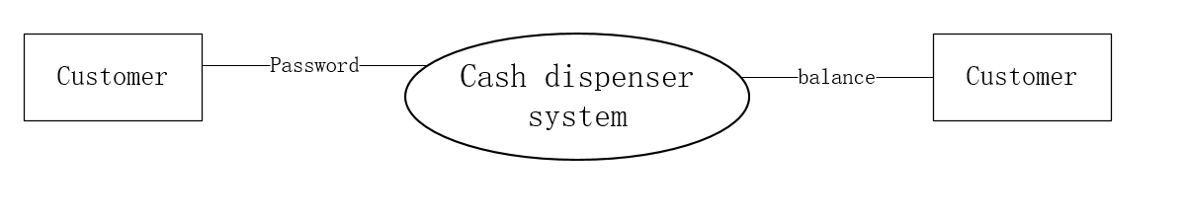
- Level0 DFD
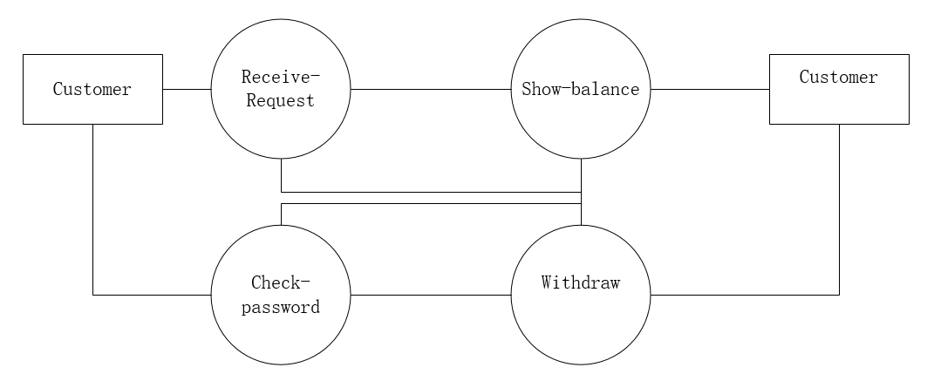
3. Level1 DFD
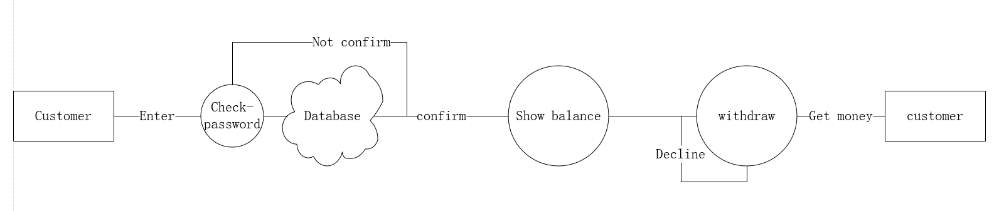

2. Draw Use Case Diagram for a Blog Website
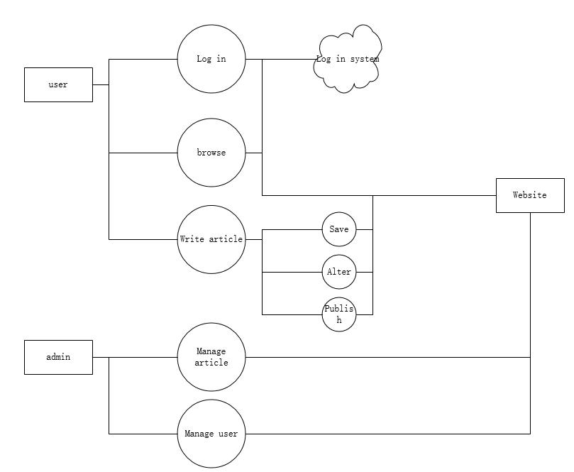
数据处理分析：(Experiment process and content)

深圳大学学生实验报告用纸

指导教师批阅意见：

成绩评定：

指导教师签字：
2019年12月25日
备注：
注：1、报告内的项目或内容设置，可根据实际情况加以调整和补充。
2、教师批改学生实验报告时间应在学生提交实验报告时间后10日内。

